# KJSCE/IT/SYBTech/SEM IV/AD/2022-23



**Experiment No. 9**

**Title: Execution of OLAP Operations**

**Batch: B2 Roll No.: 16010421119 Experiment No.:9**

**Aim:** Execution of OLAP operations

**Resources needed: MySQL, Postgres**

**Theory**

## OLAP:

In computing, online analytical processing, or OLAP is an approach to answering multi- dimensional analytical (MDA) queries. OLAP is part of the broader category of business intelligence, which also encompasses relational database report writing and data mining. Typical applications of OLAP include business reporting for sales, marketing, management reporting, business process management (BPM), budgeting and forecasting, financial reporting and similar areas, with new applications coming up, such as agriculture. The term OLAP was created as a slight modification of the traditional database term OLTP (Online Transaction Processing).

OLAP tools enable users to analyze multidimensional data interactively from multiple perspectives. OLAP consists of three basic analytical operations: consolidation (roll-up), drill- down, and slicing and dicing. Consolidation involves the aggregation of data that can be accumulated and computed in one or more dimensions. For example, all sales offices are rolled up to the sales department or sales division to anticipate sales trends. By contrast, the drill-down is a technique that allows users to navigate through the details. For instance, users can view the sales by individual products that make up a region’s sales. Slicing and dicing is a feature whereby users can take out (slicing) a specific set of data of the OLAP cube and view (dicing) the slices from different viewpoints.

OLAP queries can be implemented by using analytical SQL functions

Oracle has extensions to ANSI SQL to allow to quickly computing aggregations and rollups. These new statements include:

* rollup
* cube
* grouping

These simple SQL operators allow creating easy aggregations directly inside the SQL.

## Creating tabular aggregates with ROLLUP:

ROLLUP enables an SQL statement to calculate multiple levels of subtotals across a specified group of dimensions. It also calculates a grand total. ROLLUP is a simple extension to the GROUP BY clause, so its syntax is extremely easy to use. Create cross-tabular reports with CUBE:

In multidimensional jargon, a “cube” is a cross-tabulated summary of detail rows. CUBE enables a SELECT statement to calculate subtotals for all possible combinations of a group of dimensions. It also calculates a grand total.

This is the set of information typically needed for all cross-tabular reports, so CUBE can calculate a cross-tabular report with a single select statement

**Activities:**

# Create a dataset in PostgreSQL and MySQL

1. Apply rollup and cube operations to the same

**Postgresql code :-**

create table students(

s_name text,

roll_no integer,

branch varchar(50),

sid integer );

INSERT INTO students values('ABC', 25, 'IT',15024);

INSERT INTO students values('xyz', 26, 'Comps',15025);

INSERT INTO students values('pqr', 27, 'IT',15026);

INSERT INTO students values('mno', 28, 'Mech',15027);

INSERT INTO students values('def', 29, 'extc',15028);

Select * from students

**Postgres SS:-**

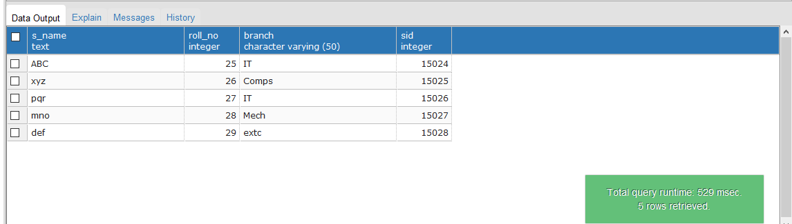

ROLLUP Code

select sid,s_name,count(roll_no) as total_student from students group by cube (s_name,sid)

order by sid;

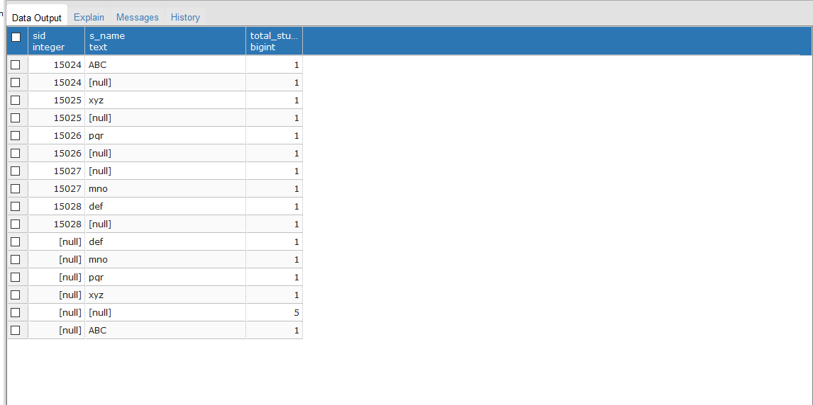

CUBE:-

select sid,s_name,count(roll_no) as total_student from students group by rollup ( s_name, sid)

order by 1, 2;

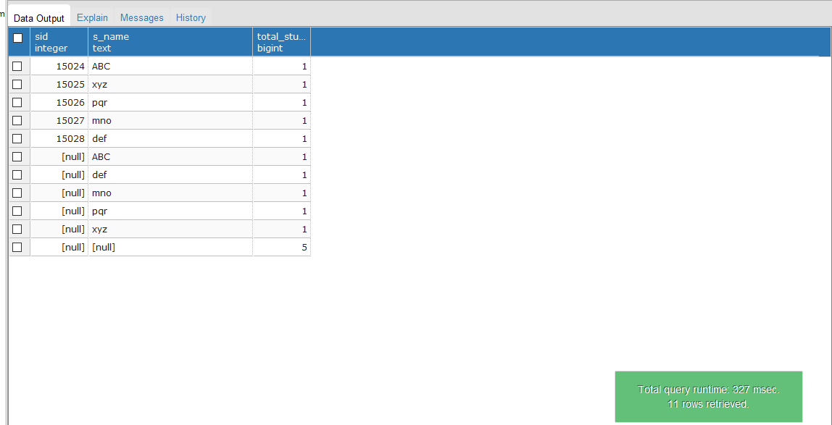

MYSQL

create table students(

s_name text,

roll_no integer,

branch varchar(50),

sid integer );

INSERT INTO students values('ABC', 25, 'IT',15024);

INSERT INTO students values('xyz', 26, 'Comps',15025);

INSERT INTO students values('pqr', 27, 'IT',15026);

INSERT INTO students values('mno', 28, 'Mech',15027);

INSERT INTO students values('def', 29, 'extc',15028);

Select * from students;

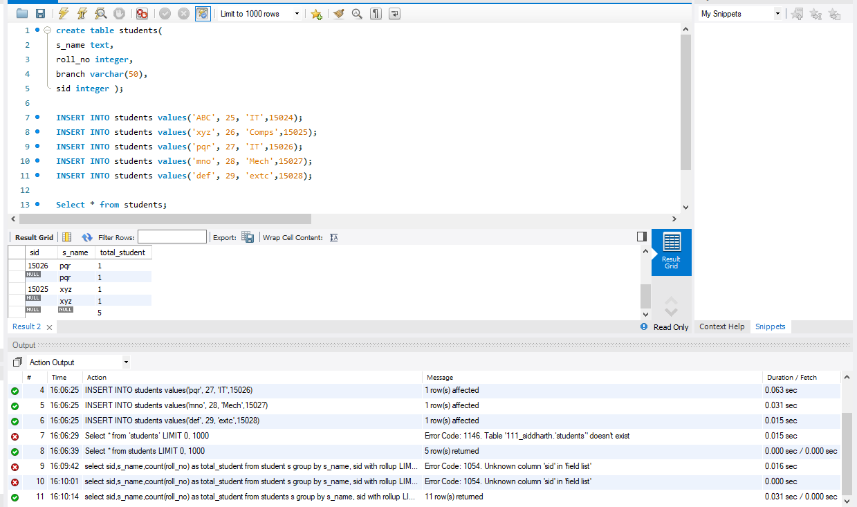

**ROLLUP CODE: -**

select sid,s_name,count(roll_no) as total_student from students

s group by s_name, sid with rollup

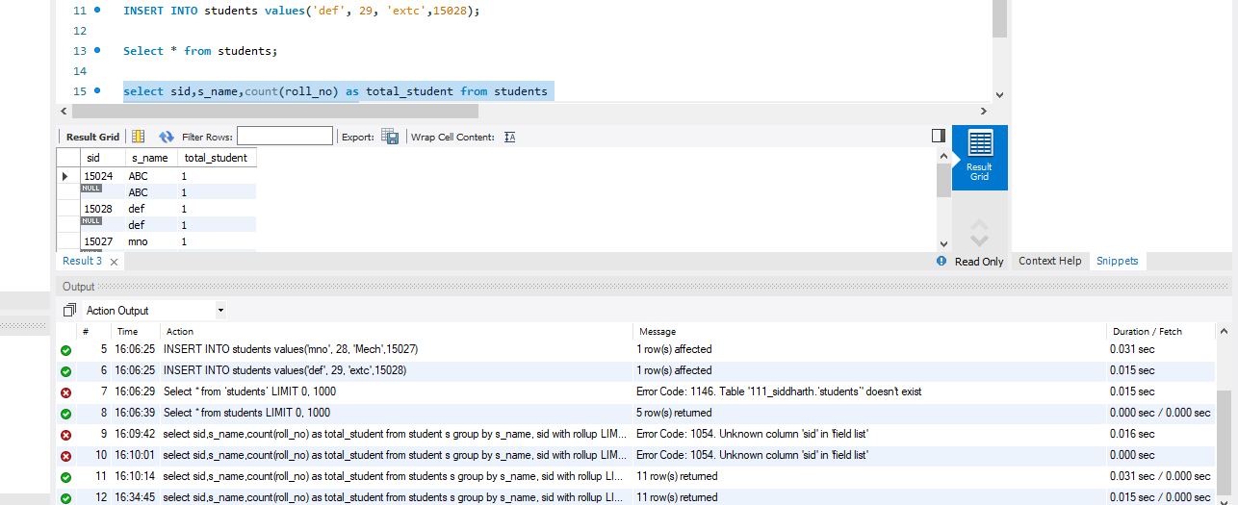

CUBE CODE: -

select sid,s_name,count(roll_no) as total_student from students group by s_name,sid with

cube;

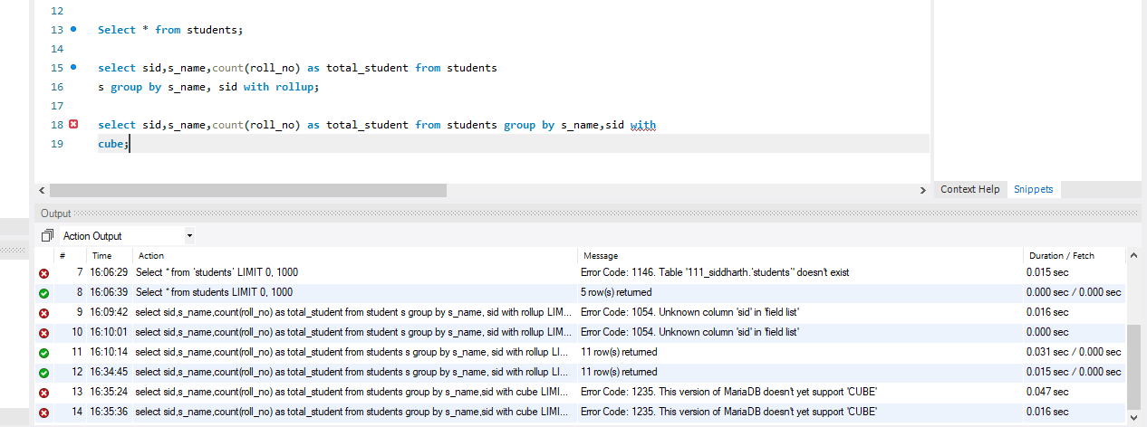

**Questions:**

1. **Elaborate on the operations applied and results generated to your dataset**

**Roll up:**It is just opposite of the drill-down operation. It performs aggregation on the OLAP cube. It can be done by:

* Climbing up in the concept hierarchy
* Reducing the dimensions

1. **Explain if Drill-down, Drill-across can be applied in relational database, Justify with a query implementation.**

A way of viewing related items of a [**Dimension**](http://olap.com/learn-bi-olap/olap-bi-definitions/dimension/)as defined in a [**Hierarchy**](http://olap.com/learn-bi-olap/olap-bi-definitions/hierarchy/) by expanding [**Members**](http://olap.com/learn-bi-olap/olap-bi-definitions/dimension-member/) to access a more detailed data range; put simply, this means displaying [**Child Members**](http://olap.com/learn-bi-olap/olap-bi-definitions/child-member/) associated with a specific [**Parent Member**](http://olap.com/learn-bi-olap/olap-bi-definitions/parent-member/) or [**Aggregate Member**](http://olap.com/learn-bi-olap/olap-bi-definitions/aggregate-member/)within a defined Hierarchy.

**Outcomes:**

**CO4: Apply ETL processing and OLAP on Warehouse Data**

**Conclusion: (Conclusion to be based on the outcomes achieved)**

**We can conclude that we have learnt about OLAP**

**Grade: AA / AB / BB / BC / CC / CD /DD**

**Signature of faculty in-charge with date**

**References:**

# Paulraj Ponniah, “Data Warehousing: Fundamentals for IT Professionals”, Wiley India